Working conditions
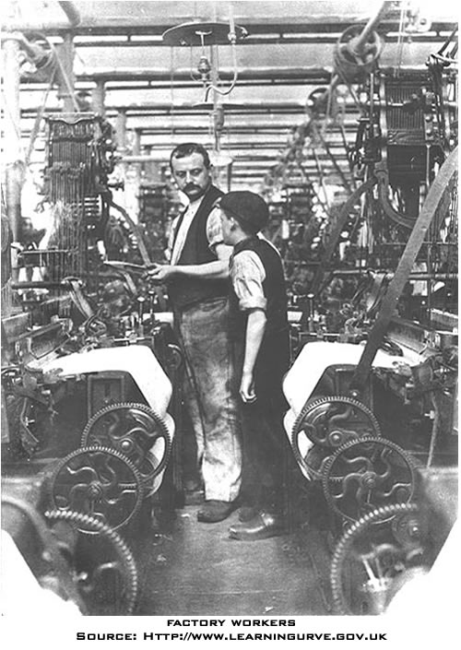
What were the working conditions like during the Industrial Revolution? Well, for starters, the working class—who made up 80% of society—had little or no bargaining power with their new employers. Since population was increasing in Great Britain at the same time that landowners were enclosing common village lands, people from the countryside flocked to the towns and the new factories to get work. This resulted in a very high unemployment rate for workers in the first phases of the Industrial Revolution. Henry Mayhew, name his title or role, studied the London poor in 1823, and he observed that “there is barely sufficient work for the regular employment of half of our labourers, so that only 1,500,000 are fully and constantly employed, while 1,500,000 more are employed only half their time, and the remaining 1,500,000 wholly unemployed” (Thompson 250). As a result, the new factory owners could set the terms of work because there were far more unskilled laborers, who had few skills and would take any job, than there were jobs for them. And since the textile industries were so new at the end of the 18th century, there were initially no laws to regulate them. Desperate for work, the migrants to the new industrial towns had no bargaining power to demand higher wages, fairer work hours, or better working conditions. Worse still, since only wealthy people in Great Britain were eligible to vote, workers could not use the democratic political system to fight for rights and reforms. In 1799 and 1800, the British Parliament passed the Combination Acts, which made it illegal for workers to unionize, or combine, as a group to ask for better working conditions.
Many of the unemployed or underemployed were skilled workers, such as hand weavers, whose talents and experience became useless because they could not compete with the efficiency of the new textile machines. In 1832, one observer saw how the skilled hand weavers had lost their way and were reduced to starvation. “It is truly lamentable to behold so many thousands of men who formerly earned 20 to 30 shillings per week, now compelled to live on 5, 4, or even less” (284).
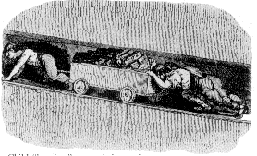
For the first generation of workers—from the 1790s to the 1840s—working conditions were very tough, and sometimes tragic. Most laborers worked 10 to 14 hours a day, six days a week, with no paid vacation or holidays. Each industry had safety hazards too; the process of purifying iron, for example, demanded that workers toiled amidst temperatures as high as 130 degrees in the coolest part of the ironworks (Rosen 155). Under such dangerous conditions, accidents on the job occurred regularly. A report commissioned by the British House of Commons in 1832 commented that "there are factories, no means few in number, nor confined to the smaller mills, in which serious accidents are continually occurring, and in which, notwithstanding, dangerous parts of the machinery are allowed to remain unfenced" (Sadler). The report added that workers were often "abandoned from the moment that an accident occurs; their wages are stopped, no medical attendance is provided, and whatever the extent of the injury, no compensation is afforded" (Sadler). As the Sadler report shows, injured workers would typically lose their jobs and also receive no financial compensation for their injury to pay for much needed health care.
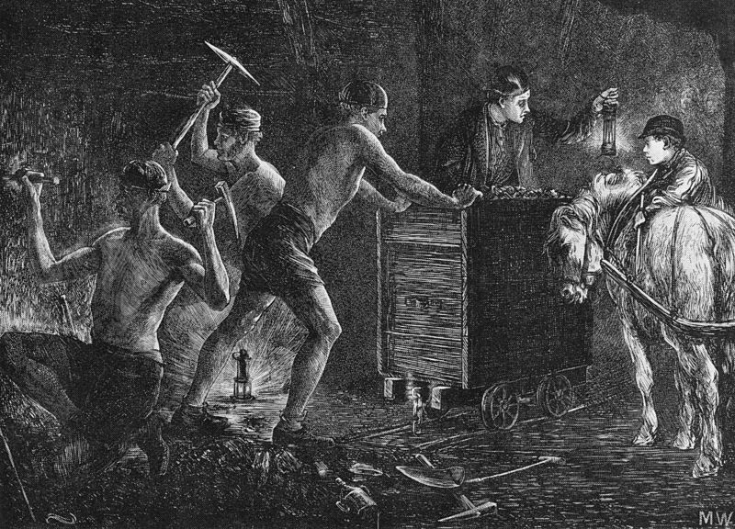
Life in the factory was most challenging for the first generation of industrial workers who still remembered the slower and more flexible pace of country life. Factory employers demanded a complete change of pace and discipline from the village life. Workers could not wander over to chat with their neighbors or family as they would have done while working in the country. They could not return to the village during harvest time to help their families, unless they wanted to lose their jobs. Instead, they were no longer their own bosses; foremen and overseers supervised a new working culture to insure that workers’ actions were focused and efficient. A few workers were able to improve their lot by going into business for themselves or winning a job as a supervisor, But the majority saw very little social mobility.
Document Questions (40 pts.)

1. What is a skilled worker and how did the innovations of the 1st Industrial Revolution effect the skilled workers. Cite 2 pieces of evidence to support your answer.

2. How did the Combination Act that was passed by the British Parliament in 1800 allow the factories to continue to get away with unfair working conditions and hours? Cite 1 piece of evidence to support your answer.

3. What does the picture at the bottom of page 1 exemplify and how does that become a major problem of the 1st Industrial Revolution? Cite 1 piece of evidence to support your answer.

4. What is the “sadler report” and what was the purpose behind it? Cite 2 pieces of evidence to support your answer.

