World History
Unit 2: The Second Agricultural Revolution
Check for Understanding
30 pts.

- In what century did the Second (“new”) Agricultural Revolution take place?

- 16th
- 17th
- 18th
- 19th

- Part A/Part B

Part A

Which of the following arguments can be made concerning the three-field system?

- It allowed for the greatest use and development of the land.
- Agricultural production was not nearly as efficient as it could have been due to its use.
- Over time, an increase in livestock cultivation occurred due to its implantation.

Part B

Which of the following pieces of information best supports your answer in Part A?

- “..the Enlightenment was discovering new ways to grow better crops.”
- “..crop yields were down, forcing peasants to use most of the land for grain crops, and so on.”
- “..it made previously useless and marginal land useful, thus expanding the amount of land under cultivation.”

- According to the article, the heavy plow

- made work more difficult because of its weight.
- delayed agricultural development because of its economic cost.
- hurt crop yields due its indirect destruction and displacement of soil nutrients.
- was an essential piece of technology during the Second Agricultural Revolution.

- Peasants tended not to experiment with new farming techniques due to the fact that they

- did not understand them.
- were limited to the least fertile soil.
- had to agree as a community on agricultural changes.
- Higher crop yields resulted in a higher percentage of taxes they had to pay.

- Which of the following statements best summarizes why the middle class became interested in new agricultural techniques during the 1700’s?

- “Scientific farming lead to less pollution and better use of the soil.”
- “New farming techniques led to a general rise in the nutritional quality of
food.”
- “The middle class was educated and thus intrigued by the new possibilities that
might grow out of scientific farming.”
- “Economic motivations were the preeminent factor in the middle class’
employment of scientific farming.”

6. The Four-Field System (Crop Rotation)

- led to greater crop production.
- was focused primarily on livestock.
- resulted in a greater demand for labor.
- indirectly brought about an increase in infant mortality.

- The Enclosure Movement

- was a failure.
- a decrease in the supply of meat protein.
- allowed the common people to tame the land.
- resulted in scientific farming and better crop yields.

- Which of the following is true concerning the Enclosure Method?

- it required little space
- it required larger tracts of land
- it never produced the crop yields farmers thought it would
- it had a disastrous effect on the crops and livestock due to the spread of disease and sickness

9. 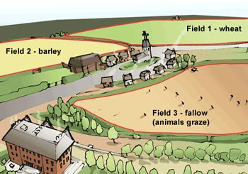

The following questions have TWO parts. First, answer Part A. Then, Part B.

PART A

Which of the following systems is depicted?

- Three-Field System
- Four-Field System
- Enclosure Method

PART B

Which of the following can be inferred based on the information in the drawing?

- Crop yields in this town were extremely high
- Crop yields lagged behind by a significant percentage
- Livestock gains would have been significantly higher than in other towns

10.

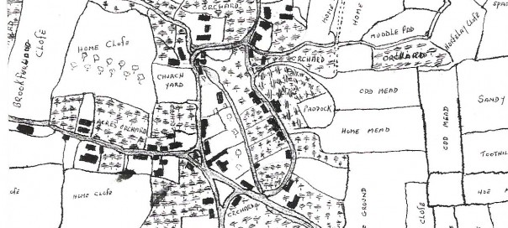

PART A

Which of the following systems is depicted?

- Three-Field System
- Four-Field System
- Enclosure Method

PART B

Which of the following can be inferred based on the drawing and outside knowledge?

- More land was given to the community as a whole
- Selective breeding and crop rotation could be more easily practiced
- Livestock gains were significantly lower than in other towns due to less pasture land

