World History
Introduction – Review Lesson

Clear Target – Working in small groups, TSSBAT match and create shorts descriptions of major historical periods (listed) by using the given primary and secondary sources.

Directions

- Students will be assigned to a small group
- Using the sources provided, groups are to try to and figure out for what historical period each set of documents belong.
- On a single sheet of paper for the group, identify which historical period goes
with the documents and write a two-three sentence answer in which the
said documents are used to help elaborate.

Historical Periods

The Renaissance
The Reformation
The Age of Exploration
The Age of Absolutism
The Scientific Revolution

Document(s) 1

A) B)
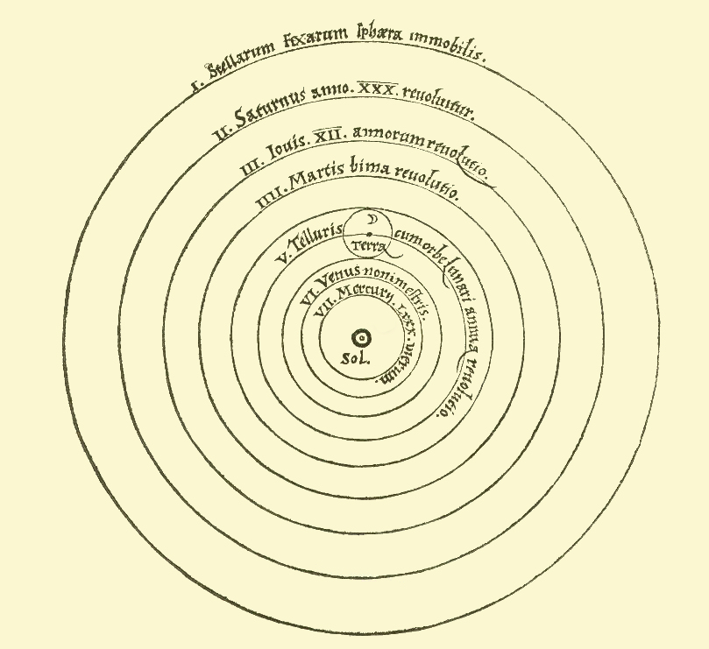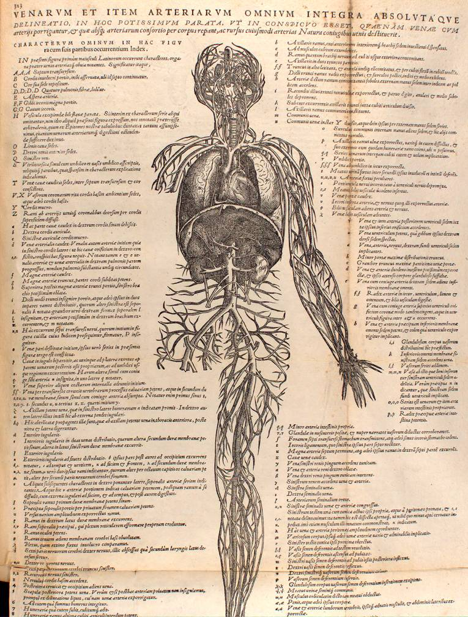

Document(s) 2

A) “All men being equal by nature because of the humanity that is their essence, nature does not cause some to be inferior to others. But in this natural equality, they are separated by other principles that render their conditions unequal and give rise to relationships and dependencies that determine their varying duties toward others and render government necessary.
...
The first distinction that subjects some persons to others is that which birth introduces between parents and children. The second distinction among persons is that which requires different employments in society and unites all in the body of which each is a member. And it is these varying occupations and dependencies that create the ties that form society among men, as those of its members form a body. This renders it necessary that a head coerce and rule the
body of society and maintain order among those who should give the public the benefit of the different contributions that their stations require of them.
....
Since government is necessary for the common good and God himself established it, it follows that those who are its subjects must be submissive and obedient. For otherwise they would resist God, and the government which should be the source of the peace and unity that make possible the public good would suffer from dissension and trouble that would destroy it....”

B)“L’etat, c’est moi” – Louis XIV

Document(s) 3
A) “For in it God’s righteousness is revealed from faith to faith, just as it is written: The righteous shall live by faith” – Romans 1:17

B) 5. The Pope has neither the will nor the power to remit any penalties beyond those he has imposed either at his own discretion or by canon law.
21. Hence those preachers of Indulgences are wrong when they say that a man is absolved and saved from every penalty by the Pope's Indulgences.
28. It is certainly possible that when the money clinks in the collection-box greed and avarice can increase; but the intercession of the Church depends on the will of God alone.
45. Christians should be taught that he who sees a needy person and passes him by, although he gives money for pardons, wins for himself not Papal Indulgences but the wrath of God.
50. Christians should be taught that, if the Pope knew the exaction's of the preachers of Indulgences, he would rather have the basilica of St. Peter reduced to ashes than built with the . skin, flesh and bones of his sheep.
81. This wanton preaching of pardons makes it difficult even for learned men to redeem respect due to the Pope from the slanders or at least the shrewd questionings of the laity.
82. For example: "Why does not the Pope empty purgatory for the sake of most holy love and the supreme need of souls? This would be the most righteous of reasons, if he can redeem innumerable souls for sordid money with which to build a basilica, the most trivial of reasons."
86. Again: "Since the Pope's wealth is larger than that of the crassest Crassi of our time, why does he not build this one basilica of St. Peter with his own money, rather than with that of the faithful poor?"
91. If, therefore, pardons were preached in accordance with the spirit and mind of the Pope, all these difficulties would be easily overcome or rather would never have arisen.
94. Christians should be exhorted to seek earnestly to follow Christ, their Head, through penalties, deaths, and hells.
95. And let them thus be more confident of entering heaven through many tribulations rather than through a false assurance of peace.

Document(s) 4
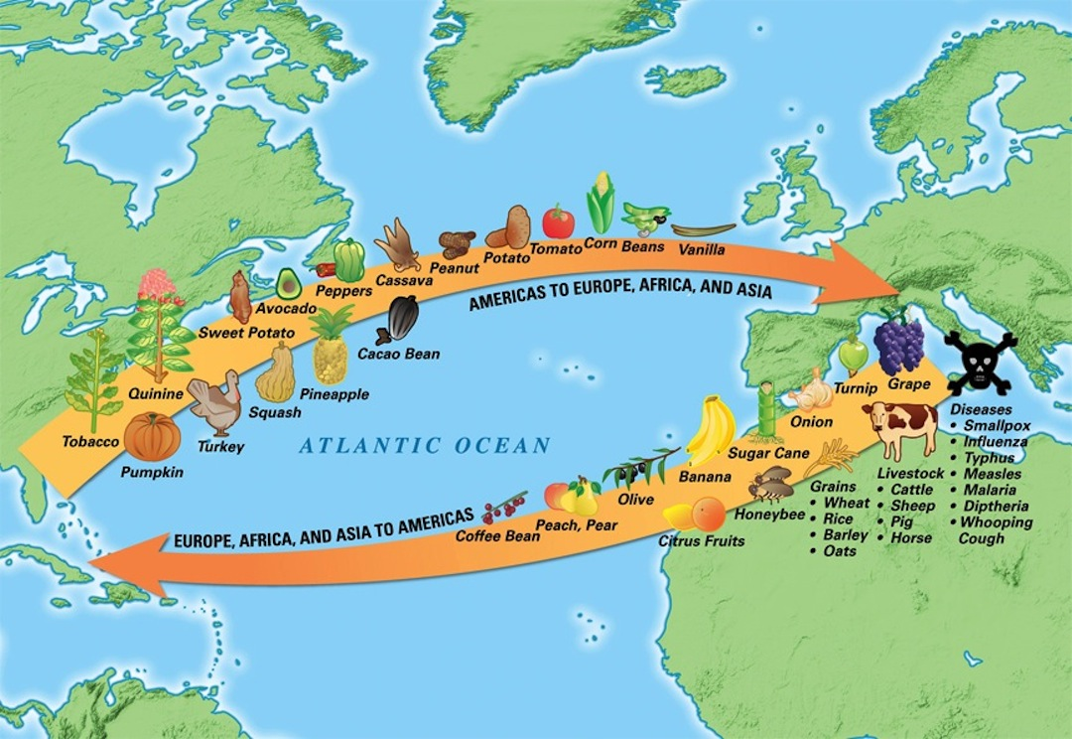
Document(s) 5
A)
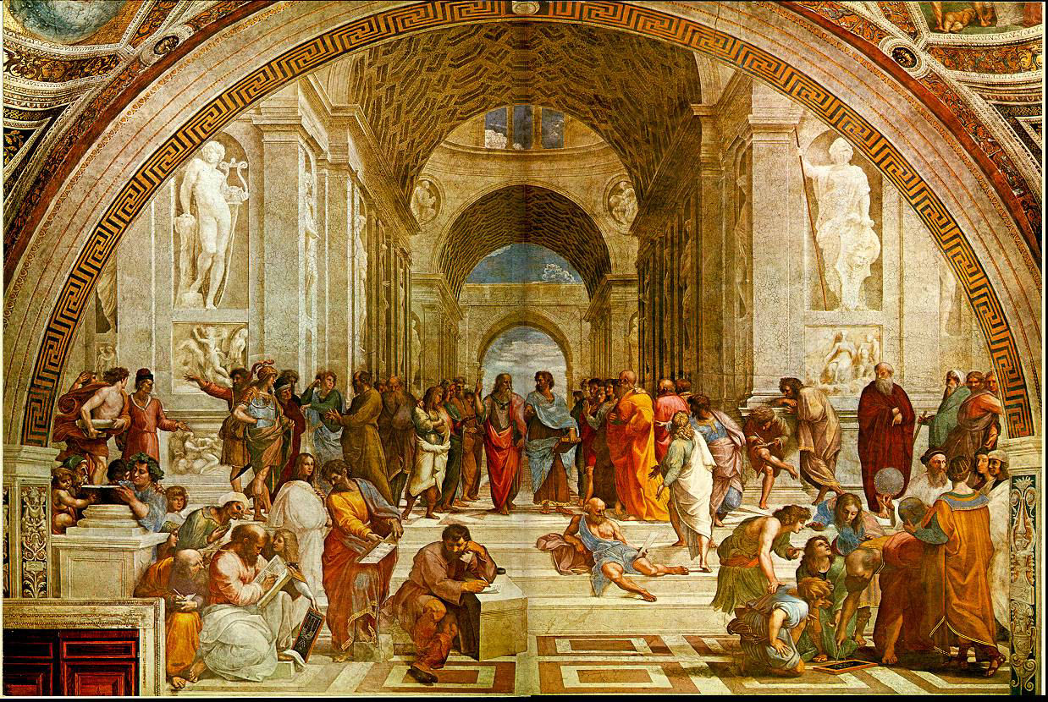
B)
