World History
The Age of Napoleon
Study Guide
30 pts.

Early Life: True or False (5 pts.):

1. T/F Napoleon was born in Corsica
2. T/F Napoleon came from a very poor family
3. T/F Napoleon excelled at both Brienne Military and the Ecole’ Militarie
4. T/F Napoleon was probably a genius
5. T/F Napoleon’s first wife was the socialite Josephine Beasuharnais

Rise to Domestic Power and Reform: Fill in the Blank (5 pts.):

6. The event which brought Napoleon and his supporters to power in France. It
occurred on 9 November 1799. ___________________________________________________

7. In the ________________________________________________ Napoleon reached an agreement
with the Catholic Church stating that Catholicism was the majority religion of
France.

8. The _____________________________ system was set up to help boost the skills needed
for a strong economy as well as creating a stronger candidate pool for the
French officer corps.

9. The _______________________________________________ was established to strengthen the
economy of France.

10. The ideas contained in the Code Napoleon grew out of the writings of the
____________________________.

Conquest – Rise and Fall: Chronological Scramble (10 pts.):

Put the following events in chronological order from first (1) to last (10).

1. B. of Waterloo ______ 6. Exile on Elba ______
2. B. of Austerlitz ______ 7. Exile on St. Helena ______
3. B. of Trafalgar ______ 8. Treaties of Tilsit ______
4. Invasion of Russia ______ 9. Penisular War Begins ______
5. Hundred Days ______ 10.Napoleon’s Death ______
Check for Understanding: Multiple Choice (10 pts.):

- The Continental System

- allowed Napoleon to thoroughly weaken the British army
- was aimed at creating the largest army in Europe
- was an idea formulated by Napoleon for a pan-European congress
- eventually weakened the economies of Napoleon’s allies, leading them to rebel against his rule

- All of the following are reasons why Napoleon is considered one of the greatest military minds ever EXCEPT:

- his movement and use of large armies
- his mastery and use of artillery
- his ability to divide and conquer his enemies on the battlefield
- his dominance in naval battles

- The dominance of Napoleon in subjugated lands helped inspire feelings of

- loyalty to Napoleon
- intense religious revival
- nationalism
- a deep appreciation for French culture

- Prior to Napoleon conquering Europe, he came to become Emperor of France through

- sheer force and military strength
- his use of reforms and plebiscite
- the defeat of Louis XVIII
- his overthrow of the Consulate

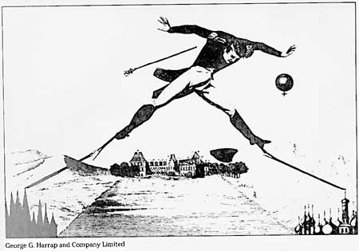

The buildings on the left are in the British style; on the right, the Russian style. A French style chateau is in the middle.

- The political cartoon above best represents the belief that

- Napoleon dominated the whole of Europe
- Napoleon was a master “juggler” of politics and power
- Napoleon’s use of the Continental System and his 1812 invasion ultimately cost him power
- Napoleon’s land empire was too large

