Ancient History
Age of Empires I: The Hittites
Map
30 pts.

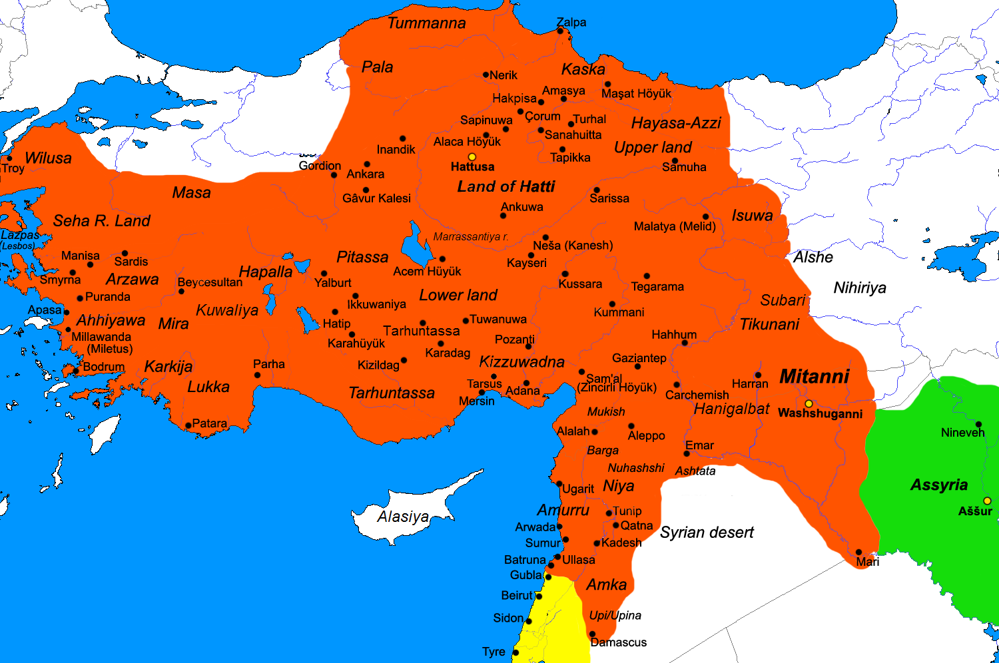

Locate and Label:

City-States (Black)

Troy Smyrna Sardis Gordian
Hattusa Tarsus Aleppo Kadesh
Damascus Sidon Tyre Mari
Assur Nineveh Washshuganni Harran

Kingdoms (RED CAPS)

ARZAWA HATTI MITANNI ASSYRIA
AMURRU KIZZUWADNA

Hittites Empire (Shade or Outline in Light Green)

Possible Expeditions (Red Lines with Arrows)

