Ancient History
Age of Empires I: The Assyrians
Map
30 pts.

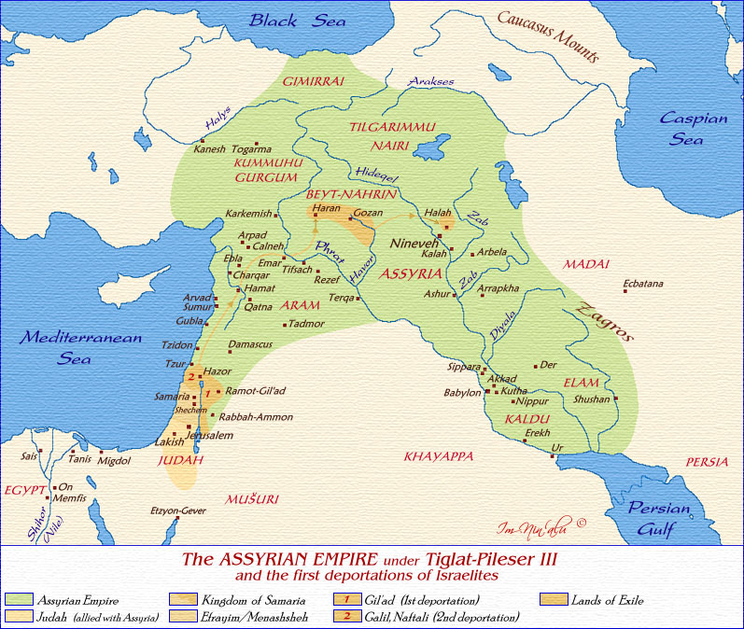

Locate and Label:

City-States (Black)

Karkemish Haran Nineveh Kalah Arbela
Ecbatana Ashur Akkad Babylon Erekh
Ur Memphis Tanis Jerusalem Samaria
Hazor Damascus Ebla Halah Gozan

Kingdoms (RED CAPS)

ASSYRIA MADAI ELAM KALDU EGYPT JUDAH

Empires and Conquest (Shading)

Lands of Exile (Light Red)
Judah (Light Brown)
Samaria (Light Yellow)
Gilead – 1st and 2nd Deportations (Light Orange)

Tiglat-Pileser III’s Empire (Light Green)

