World History
Unit 2: Working/Living Conditions – Industrial Rev.
Document Based Analysis
30 pts.

Documents

C. T. Thackrah, "The Effects of Arts, Trades and Professions, and of Civic States Habits of Living, on Health and Longevity.” 1844

No man of humanity can reflect without distress on the state of thousands of children roused from their beds at any early hour, hurried to the mills, and kept there till a late hour of night…kept in an atmosphere impure loaded with noxious dust. Recreation is out of the question. There is scarcely time for meals…I stood in Oxford-row, Manchester, and observed the streams of operatives as they left the mills. The children were almost universally ill-looking, small, sickly, barefoot, and ill-clad.

James Myles, "Dundee Republic of Letters", 1850

About a week after I became a mill boy, I was seized with a strong, heavy sickness, that few escape on first becoming factory workers. The cause of this sickness which is known by the name of 'mill fever', is the pestiferous atmosphere produced by so many breathing in a confined place, together with the heat and exhalations of grease and oil. All these causes are aggravated in the winter time by the immense destruction of pure air by the gas that is needed to light the establishment. This fever does not often lay the patient up. It is slow, dull, and painfully wearisome in its operation. It produces a sallow and debilitated look, destroys rosy cheeks

Speech of a pro-factory regulation orator in Charles Dickens’ novel, Hard Times
(1854)

“‘Oh my friends, the down-trodden operatives of Coketown! Oh my friends and fellow
countrymen, the slaves of an iron-handed and a grinding despotism! Oh my friends and fellow-sufferers, and fellow-workmen, and fellow-men! I tell you that the hour is come, when we must rally round one another as One united power, and crumble into dust the oppressors that too long have battened upon the plunder of our families, upon the sweat of our brows, upon the labour of our hands, upon the strength of our sinews, upon the God-created glorious rights of Humanity, and upon the holy and eternal privileges of Brotherhood!’ ‘Good!’ ‘Hear, hear, hear!’ ‘Hurrah!’ and other cries arose in many voices from various parts of the densely crowded and suffocatingly close Hall . . .”

Jacob Riis and Others – Photographs/Drawings
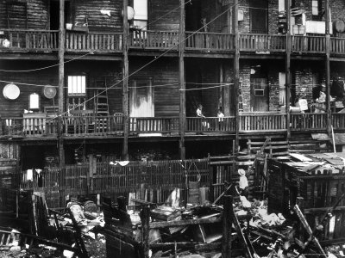

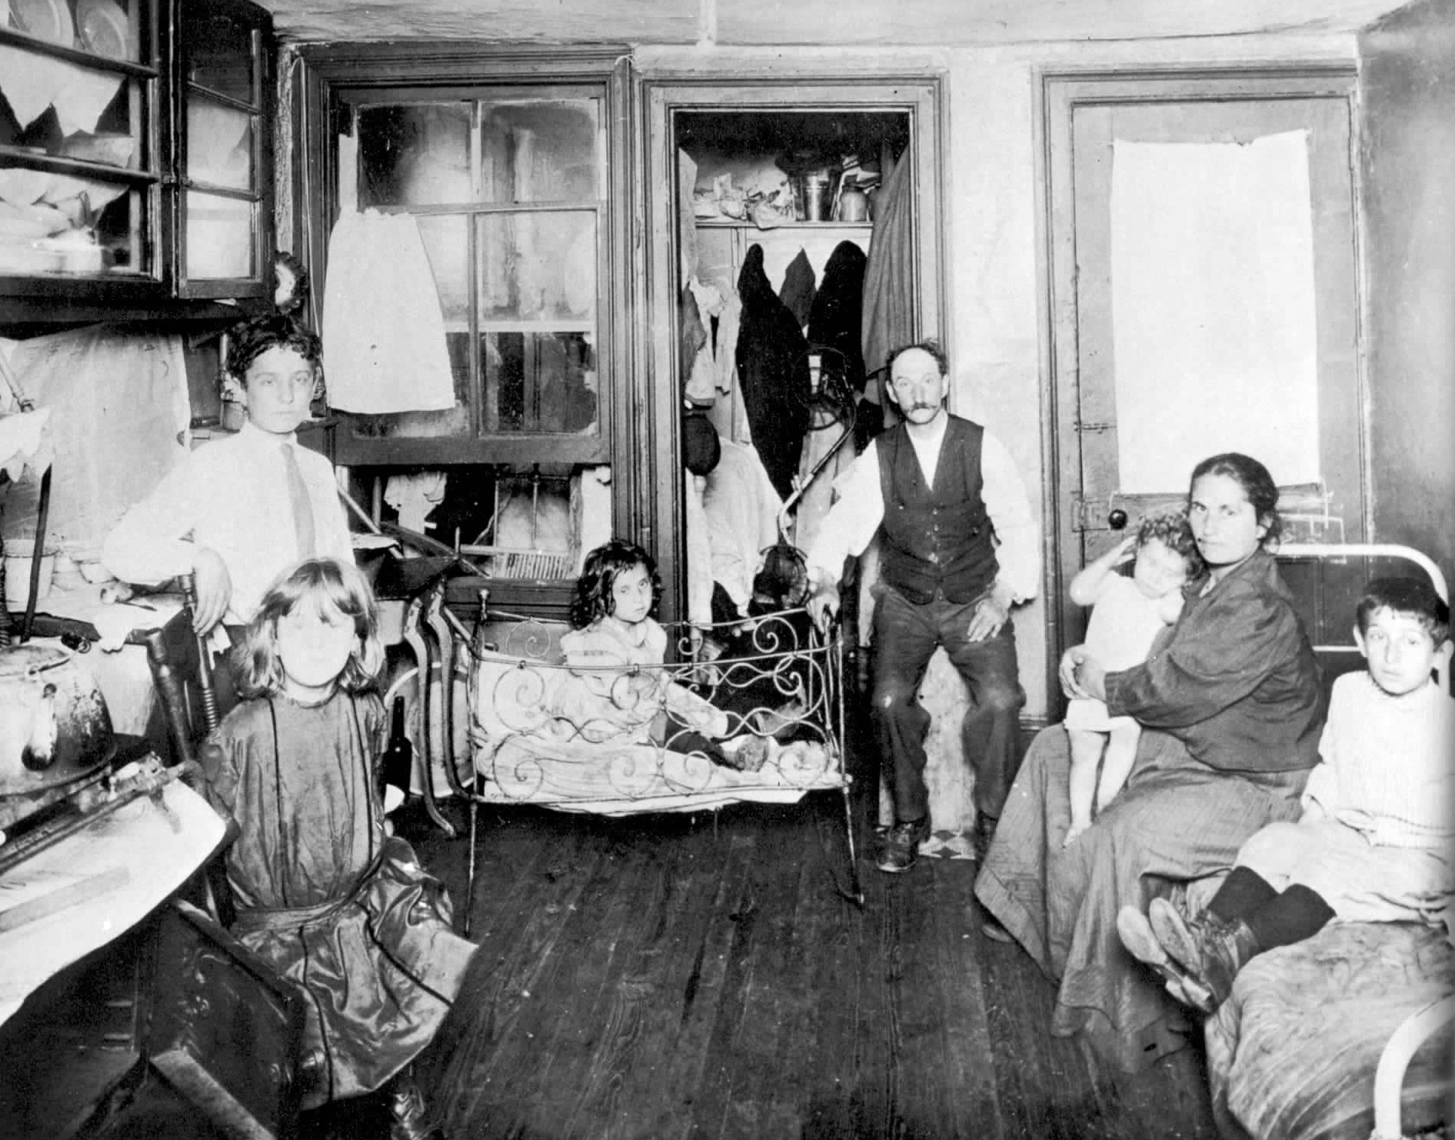
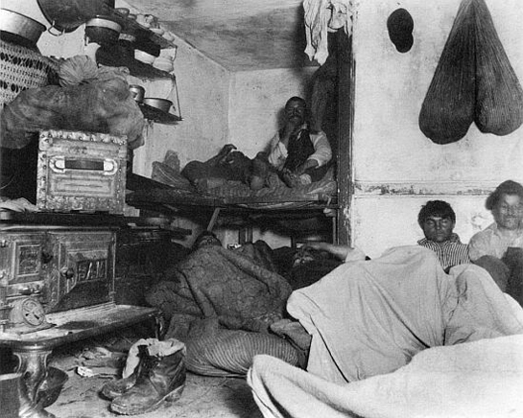

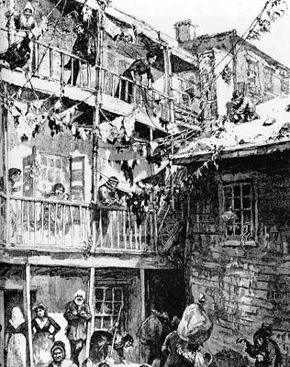

 | How does this document or picture describe working or living conditions in during the Industrial Revolution? | Support your answer with citation from the text.
C. T. Thackrah

"The Effects of Arts, Trades and Professions, and of Civic States Habits of Living, on Health and Longevity.” 1844
James Myles

"Dundee Republic of Letters", 1850

Speech of a pro-factory regulation orator in Charles Dickens’ novel, Hard Times
(1854)

Jacob Riis/Others Photos

