Ancient History
The Sumerians: Jemdet Nasr and Dynastic Periods
Review
20 pts.

Jemdet Nasr Period

- The Jemdet Nasr period of Sumerian history is marked by a movement from the southern reaches of Sumer to

- the great city of Babylon.
- the area east of the Tigris River known as Elam.
- the land north of Sumer towards the bottleneck of Mesopotamia.
- a mass exodus west towards the port cities and lands of the Levant.

- The pottery of the Jemdet Nasr period is marked by

- a very elementary design.
- the least advanced pottery during the whole of Sumerian history.
- a greater sophistication than the Uruk period as well as greater detail in art and color.
- the most advanced technology seen in the entire history of the Ancient Near East and surrounding areas.

- Urbanization during this period is marked by

- larger cities (population) and more of them.
- smaller cities and less of them.
- less organized cities without any form of civil engineering or planning evident.
- the movement of the populous away from the cities and back to the marsh lands and agricultural camps.

- The greatest socio-political change that took place during the transition period from the Jemdet Nasr Period to the Early Dynastic Period was

- movement to wedge-shaped cuneiform
- better irrigation techniques
- a ruling class or king based on military might and leadership
- the expansion of the Sumerian city-states throughout Mesopotamia

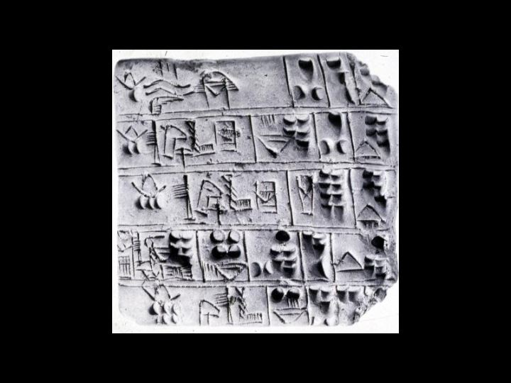

- How can the cuneiform writing above be identified with the Jemdet Nasr Period?

- It contains pictographs.
- Sentence structure is identified by the vertical lines.
- There is evidence of wedge-shaped symbols being used.
- The structure of the writing has moved from a north-south orientation to an east-west orientation.

Dynastic Period

- The Dynastic Period in Sumerian history is characterized by

- the rule of the ensi.
- a general movement to a unified kingdom known as Sumer.
- the rule of the lugal as urbanization and the need for organization became greater.
- a complete collapse of the priesthood and the religious beliefs of for which they oversaw.

- The famous Sumerian King’s List

- is at best suspect.
- is the best source for understanding the history of the period.
- contains information about the entirety of Sumerian political history.
- Proved to be a fake during examination by the antiquity authorities of Iraq.

- The history of the Dynastic Period can best be found by

- looking at the temple scrolls.
- reading the great Sumerian myths and stories.
- reading over the accounts left by the king’s scribes.
- Looking over the censuses that were undertaken throughout this period.

- An increase in urbanization during this period most likely occurred due to

- immigration.
- A greater worship of Inanna..
- better irrigation and farming techniques.
- an increase in the number of captured enemies being brought to the cities.

- The greatest weakness of the Sumerian state is that they

- were not strong militarily.
- were not unified militarily or politically
- had no navy or ability to defend the rivers
- did not have as advanced of technology as the tribes that surrounded them.

