World History
10-3: Unifying Italy
Review Sheet
35 pts.

Matching (10 pts.):

1. Camillio Cavour _____ A. Emperor of France; helped expel Austria
2. Giuseppe Mazzini _____ B. architect of Italian unification; prime minister
3. Victor Emmanuel _____ C. founder of Red Shirts and ardent nationalist
4. Napoleon III _____ D. first King of Italy (unified)
5. Giuseppe Garibaldi _____ E. founder of Young Italy; Italian nationalist

Multiple Choice (10 pts.) :

- Prior to 1815, the Apennine Peninsula (Italy)

- was securely unified under the banner of the Pope and the Church
- was under full control of the French
- was divided among local factions and loyalties as well as foreign rulers
- suffered from a lack of a common language

- The term Risorgimento is used to describe the process of

- freedom fighters rebelling against the Papacy
- Italian unification
- driving Austria out of Venice
- writing new literature and creating new art in the early part of the 19th century in Italy

- Cavour’s long-term goal was to

- end Austrian power in Italy
- end Prussian power in Italy
- make Sardinia Italy’s capital
- stimulate industry

- Which of the following best describes the policies of Cavour in regards towards Italian unification?

- lawful
- pragmatic
- sinister
- weak and unresponsive

- All of the following were true of Camillo de Cavour EXCEPT:

- he favored a constitutional government in Italy
- he encouraged economic development by expanding industry
- he encouraged economic development by building railroads and canals
- he spend large amounts of money to and equip a large navy

Primary Document Analysis (15 pts.):

Document 1

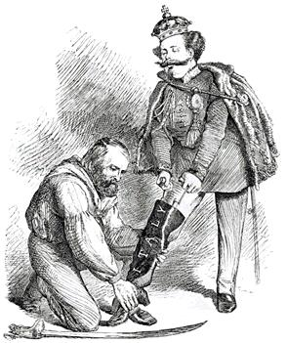

- Who is the figure kneeling? (1 pt.)

- Who is the figure standing? (1 pt.)

- What does the boot represent? (1 pt.)

- What event does the cartoon above represent? (3 pts.)

