World History
Unit 5: The Cold War
Chruchill- Iron Curtain Speech
Document Analysis

Winston Churchill gave this speech at Westminster College, in Fulton, Missouri, after receiving an honorary degree. With typical oratorical skills, Church introduced the phrase "Iron Curtain" to describe the division between Western powers and the area controlled by the Soviet Union. As such the speech marks the onset of the Cold War. The speech was very long, and here excerpts are presented.

The United States stands at this time at the pinnacle of world power. It is a solemn moment for the American democracy. For with this primacy in power is also joined an awe-inspiring accountability to the future. As you look around you, you must feel not only the sense of duty done, but also you must feel anxiety lest you fall below the level of achievement. Opportunity is here now, clear and shining, for both our countries. To reject it or ignore it or fritter it away will bring upon us all the long reproaches of the aftertime. It is necessary that constancy of mind, persistency of purpose, and the grand simplicity of decision shall rule and guide the conduct of the English-speaking peoples in peace as they did in war. We must, and I believe we shall, prove ourselves equal to this severe requirement. I have a strong admiration and regard for the valiant Russian people and for my wartime comrade, Marshal Stalin. There is deep sympathy and goodwill in Britain -- and I doubt not here also -- toward the peoples of all the Russias and a resolve to persevere through many differences and rebuffs in establishing lasting friendships. It is my duty, however, to place before you certain facts about the present position in Europe. From Stettin in the Baltic to Trieste in the Adriatic an iron curtain has descended across the Continent. Behind that line lie all the capitals of the ancient states of Central and Eastern Europe. Warsaw, Berlin, Prague, Vienna, Budapest, Belgrade, Bucharest and Sofia; all these famous cities and the populations around them lie in what I must call the Soviet sphere, and all are subject, in one form or another, not only to Soviet influence but to a very high and in some cases increasing measure of control from Moscow. The safety of the world, ladies and gentlemen, requires a unity in Europe, from which no nation should be permanently outcast. It is from the quarrels of the strong parent races in Europe that the world wars we have witnessed, or which occurred in former times, have sprung. Twice the United States has had to send several millions of its young men across the Atlantic to fight the wars. But now we all can find any nation, wherever it may dwell, between dusk and dawn. Surely we should work with conscious purpose for a grand pacification of Europe within the structure of the United Nations and in accordance with our Charter. In a great number of countries, far from the Russian frontiers and throughout the world, Communist fifth columns are established and work in complete unity and absolute obedience to the directions they receive from the Communist center. Except in the British Commonwealth and in the United States where Communism is in its infancy, the Communist parties or fifth columns constitute a growing challenge and peril to Christian civilization. The outlook is also anxious in the Far East and especially in Manchuria. The agreement which was made at Yalta, to which I was a party, was extremely favorable to Soviet Russia, but it was made at a time when no one could say that the German war might not extend all through the summer and autumn of 1945 and when the Japanese war was expected by the best judges to last for a further eighteen months from the end of the German war. I repulse the idea that a new war is inevitable -- still more that it is imminent. It is because I am sure that our fortunes are still in our own hands and that we hold the power to save the future, that I feel the duty to speak out now that I have the occasion and the opportunity to do so. I do not believe that Soviet Russia desires war. What they desire is the fruits of war and the indefinite expansion of their power and doctrines. But what we have to consider here today while time remains, is the permanent prevention of war and the establishment of conditions of freedom and democracy as rapidly as possible in all countries. Our difficulties and dangers will not be removed by closing our eyes to them. They will not be removed by mere waiting to see what happens; nor will they be removed by a policy of appeasement. What is needed is a settlement, and the longer this is delayed, the more difficult it will be and the greater our dangers will become. From what I have seen of our Russian friends and allies during the war, I am convinced that there is nothing they admire so much as strength, and there is nothing for which they have less respect than for weakness, especially military weakness. For that reason the old doctrine of a balance of power is unsound. We cannot afford, if we can help it, to work on narrow margins, offering temptations to a trial of strength. Last time I saw it all coming and I cried aloud to my own fellow countrymen and to the world, but no one paid any attention. Up till the year 1933 or even 1935, Germany might have been saved from the awful fate which has overtaken her and we might all have been spared the miseries Hitler let loose upon mankind. There never was a war in history easier to prevent by timely action than the one which has just desolated such great areas of the globe. It could have been prevented, in my belief, without the firing of a single shot, and Germany might be powerful, prosperous and honored today; but no one would listen and one by one we were all sucked into the awful whirlpool. We must not let it happen again. This can only be achieved by reaching now, in 1946, a good understanding on all points with Russia under the general authority of the United Nations Organization and by the maintenance of that good understanding through many peaceful years, by the whole strength of the English-speaking world and all its connections. If the population of the English-speaking Commonwealth be added to that of the United States, with all that such cooperation implies in the air, on the sea, all over the globe, and in science and in industry, and in moral force, there will be no quivering, precarious balance of power to offer its temptation to ambition or adventure. On the contrary there will be an overwhelming assurance of security. If we adhere faithfully to the Charter of the United Nations and walk forward in sedate and sober strength, seeking no one's land or treasure, seeking to lay no arbitrary control upon the thoughts of men, if all British moral and material forces and convictions are joined with your own in fraternal association, the high roads of the future will be clear, not only for us but for all, not only for our time but for a century to come. Winston Churchill - March 5, 1946

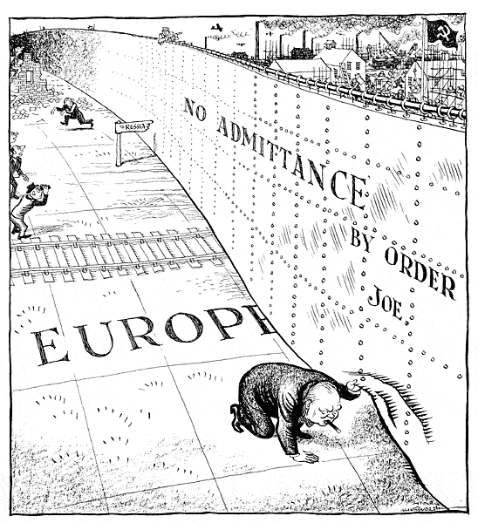

- Text – A) What is the text about? B) What was Churchill trying to prove or say?
C) Cite 3 pieces of evidence that support Question B.

- Political Cartoon – Explain the cartoon by breaking down the major individual aspects of it.

