World History
Nationalism: Austria, the Ottoman Empire, and Russia
Check for Understanding
30 pts.

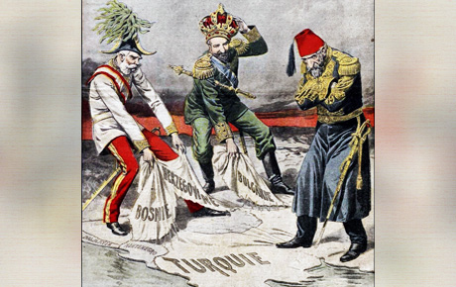

1. The political cartoon above represents the

A. failure of European powers to act on behalf of weakened Balkan states
B. dissolution of the Austro-Hungarian Empire
C. weakening state of the Ottoman Empire
D. neglect of Ottoman demands at numerous European peace settlements

2. The main theme of the cartoon above is that

A. nationalism was tearing the Ottoman Empire apart
B. the Ottoman military had not industrialized or kept pace with its
European neighbors
C. the Ottoman Empire was losing its land to European powers due to the
forces of nationalism
D. nobody could match the military might of Austria or Russia in the late
19th century

3. Which of the following statements best relates to the ideology of nationalism and
its role in the Austrian Empire during the 19th century?

A. “Franz Joseph cooperated with all major ethnic groups in trying to bring
about peaceful resolutions”
B. “the Austrian army was multinational and thus represented the harmony
of the Empire”
C. “Czechs, Magyars, Poles, Italians, and Slavs all constituted different parts
parts of the Empire and in such believed in self-autonomy”
D. “the Empire struggled with new peoples and states collected from the
remains of the Ottoman Empire”

4. Which of the following dynasties ruled Russia from 1619 to 1917?

A. Bourbon
B. Hapsburg
C. Hohenzollern
D. Romanov

5. Circle the set of Synonyms which best characterize the rule of

Alexander I / Nicholas I

A. Liberal/Reactionary
B. Progressive/Conservative
C. Semi-Progressive (Moderate)/Reactionary
D. Conservative/Progressive

6. The Decembrist Revolt of 1925 best indicates that

A. the Russian military was weaker than was thought throughout Europe
B. liberal ideals and the idea of reform were alive and well in Russia
C. socialist radicals had considerable support among Russian workers
D. Russian defense was along its borders had been substantially weakened
by a lack of industrialization

7. Czar Alexander II

A. established zemstvos, which were assemblies that allowed the rural
Russian populous to maintain control over local politics
B. liberated the Russian serfs, thereby improving the political, social, and
Economic well-being of all Russians
C. made a half-hearted effort to reform the Russian judicial system
D. reformed the Russian military and curtailed its abuses of the civilian
population

“we live as free men, but we cannot afford to live as such…work is sparse, food is as sacred as our Holy Orthodox Church, and a somber mood hangs over our villages.”

8. The quote above most likely indicates that

A. the zemstvos were not working as first thought
B. the Emancipation Edict had a negative impact on the Russian economy
C. the radical elements in Russian society were not pleased with the rule of
Alexander II
D. Russian liberalism of the 1860s was triumphant in its goals

9. Alexander III

A. was progressive in dealing with the Russian working class
B. set out to crush any hint of rebellion or dissidence
C. broke with Russian tradition and outlawed royal marriages to
non-Russian women
D. set out to unify Russian polity by creating a royal Duma

10. The Russian Revolution of 1905 and the October Manifesto

A. resulted in the abdication of the Czar
B. was immediately suppressed by Nicholas II
C. was the primary cause of the Russo-Japanese War
D. led to the formation of the Duma and the granting of civil rights

