World History
Unit 1: The Age of Revolution 1750-1850
Lesson 1-1: The Enlightenment and Its Causes
Reteaching Activity

Multiple Select:

- The Enlightenment can best be characterized as a(n)

- period in which science advanced at its greatest pace ever.
- intellectual movement in which reason was used to try and make society better.
- time in which absolute rule and power came to dominate the political landscape.
- political movement in which constitutional governments started to take hold throughout the European continent

- All of the following were causes of the Enlightenment EXCEPT:

- the weakening of absolute rule.
- the Scientific Revolution and its great method.
- the new technology that sprung forth from the Industrial Revolution
- the literacy rate throughout Europe increased during the 18th century allowing for a greater understanding of the printed word.

- The Enlightenment fulfilled the Renaissance belief in virtu by

- completely destroying the power of the Catholic Church.
- moving past art and focusing on the written word of philosophy.
- bringing forth the ideas of democracy and republicanism to the masses.
- moving from the glory of individualism to the belief that progress for civilization was possible.

- Though the Enlightenment occurred throughout central and western Europe, it was centered in and around the great city of

- Rome.
- Paris.
- London.
- Berlin.

- The Enlightenment is most generally associated with the

- 16th century.
- 17th century.
- 18th century.
- 19th century.

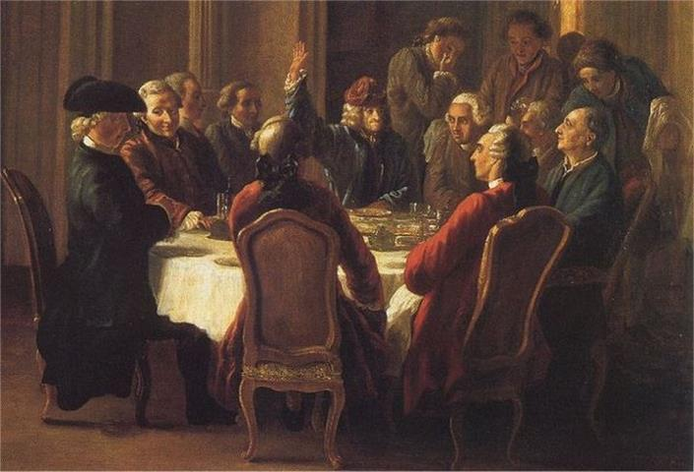

- The picture above most likely illustrates the concept that

- no women whatsoever took part in the Enlightenment.
- persons of all rank and file were allowed to participate in the Enlightenment.
- Salons were used to host private debates on important questions relating to science, nature, and society as a whole.
- the ideas of the Enlightenment were discussed and disseminated free and openly with the support of governments.

7.

“…each branch should be subjected to another so that one does not become too powerful or too dominant…there should always be a way in which the people can maintain their respective rights and not have them stripped by the autonomy of the state…the English get this best…”

- The quote above most likely came from the works of

- Hobbes
- Montesquieu
- Rousseau
- Voltaire

- The greatest consequence of the Enlightenment was the

- new found belief and interest generated by the theologians of the Church
- growing movement of people who believed in a new way of thinking
- new world view created by the great scientist of the time
- the industrial technology that came out of the movement

Matching (10 pts.):

1. Immanuel Kant _____ A. greatest work of the Enlightenment

2. Thomas Hobbes _____ B. “life, liberty, and property”

3. John Locke _____ C. editor of the Encyclopedia

4. Montesquieu _____ D. laissez-faire, free market economics

5. Voltaire _____ E. wrote the Social Contract

6. Diderot _____ F. wrote The Spirit of the Laws

7. Encyclopedia _____ G. German philosophe; defined Enlightenment

8. Rousseau _____ H. believed in, and wrote on, women’s equality

9. Wollstonecraft _____ I. known for his vigorous defense of freedom
of speech

10. Smith _____ J. developed Social Contract theory

